Project: Command & Control Traffic Generation + Detection Lab

1. Lab Setup

1.1 Objective
The objective of this project is to set up a controlled, isolated environment for simulating and detecting Command & Control (C2) traffic using open-source tools. The goal is to monitor malicious activity via a SIEM (Splunk) and demonstrate detection capabilities from both network and endpoint perspectives.

1.2 Virtual Machines Overview
VM Name | Role | Operating System | Purpose
Ubuntu | Splunk Server | Ubuntu 24.04 | Collect logs, act as a SIEM
Windows | Victim | Windows 10 Pro | Simulate endpoint + beaconing
Kali | Attacker/C2 | Kali Linux | Host Caldera (C2), Metasploit

1.3 Network Configuration
- Network Mode: Internal Network (intnet)
- Purpose:
  - Simulates a small corporate LAN
  - Prevents any C2 traffic from reaching the real internet
  - Ensures safe malware/C2 testing in isolation

Network Interfaces
VM | Adapter 1 | Adapter 2
Ubuntu | NAT | Internal Network
Windows | — | Internal Network
Kali | — | Internal Network

1.4 Static IP Addressing
All machines are configured with static IPs within the 192.168.100.0/24 subnet:
VM | IP Address | Adapter
Ubuntu | 192.168.100.10 | intnet
Windows 10 | 192.168.100.20 | intnet
Kali | 192.168.100.30 | intnet

Configuration Steps
For Ubuntu:
sudo nano /etc/netplan/01-network-manager-all.yaml
# Add:
network:
version: 2
renderer: NetworkManager
ethernets:
enp0s8:
addresses: [192.168.100.10/24]

sudo netplan apply
For Windows 10:
- Control Panel > Network & Sharing > Ethernet > Properties > IPv4
- Set:
  - IP: 192.168.100.20
  - Subnet: 255.255.255.0
  - Gateway: (leave blank)
For Kali Linux:
sudo nano /etc/network/interfaces
# Add:
auto eth0
iface eth0 inet static
address 192.168.100.30
netmask 255.255.255.0

sudo systemctl restart networking

2. Tool Installation and Configuration
This section outlines the key tools installed and configured on each virtual machine in the lab. These tools were essential for simulating adversary behavior, collecting system logs, and performing detection using a SIEM.

2.1 Splunk Installation and Configuration (Ubuntu 24.04)
Purpose: Act as the centralized SIEM for collecting and analyzing security event logs from the Windows victim machine.
Steps:
- Download and install Splunk:
wget -O splunk-latest.deb "https://download.splunk.com/products/splunk/releases/9.4.1/linux/splunk-9.4.1-e3bdab203ac8-linux-amd64.deb"
sudo dpkg -i splunk-9.4.1-e3bdab203ac8-linux-amd64.deb
sudo /opt/splunk/bin/splunk enable boot-start
sudo /opt/splunk/bin/splunk start
- Access Splunk Web UI:
Navigate to http://127.0.0.1:8000 in a browser or http://<machine_ip>:8000.
- Enable log receiving:
  - Go to Settings → Forwarding and receiving → Configure receiving
  - Add TCP port 9997
- Create a log index:
  - Go to Settings → Indexes → New Index
  - Name: win10-victim
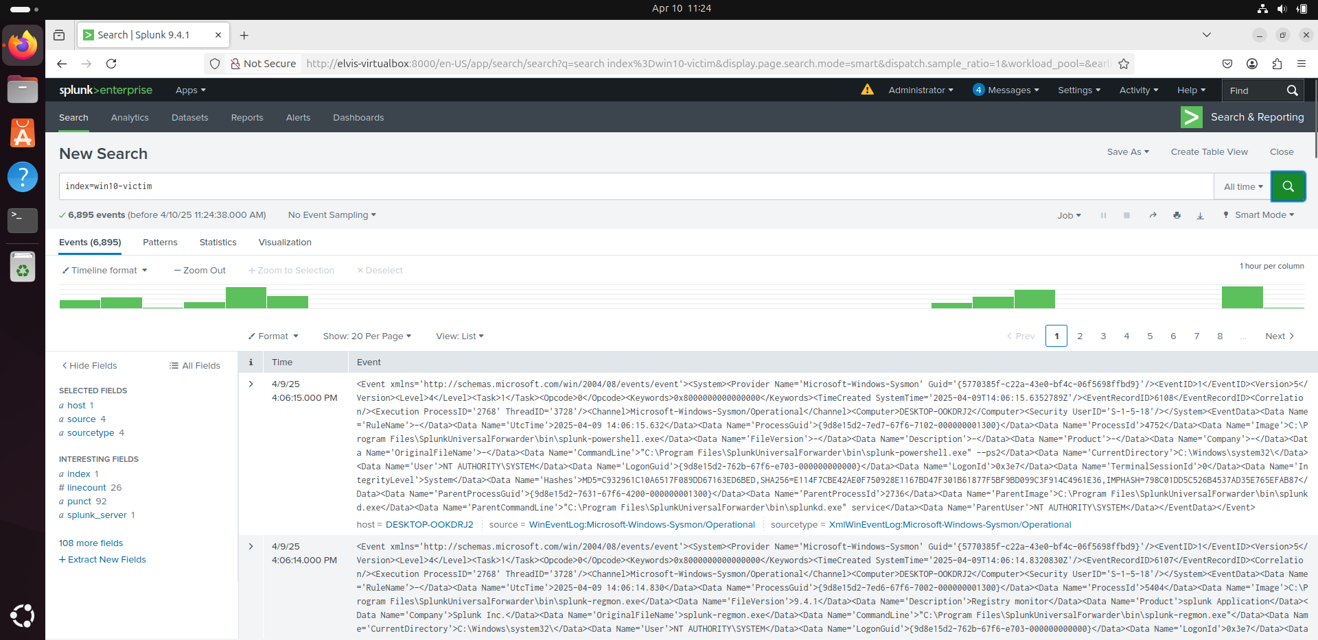

2.2 Splunk Universal Forwarder + Sysmon (Windows 10 Victim)
Purpose: Send detailed endpoint event logs (including Sysmon logs) to the Splunk server for detection and analysis.
Steps:
- Install Sysmon with a recommended configuration:
  - Download Sysmon and SwiftOnSecurity config file.
  - Install using:
sysmon.exe -accepteula -i sysmonconfig-export.xml
- Install Splunk Universal Forwarder:
  - Configure it to forward logs to the Splunk server on port 9997.
- Configure log forwarding:
  - Edit the inputs configuration file:
C:\Program Files\SplunkUniversalForwarder\etc\system\local\inputs.conf
  - Add:
[WinEventLog://Microsoft-Windows-Sysmon/Operational]
disabled = 0
index = win10-victim
renderXml = true
- Restart the Splunk Forwarder service:
Restart-Service splunkforwarder

2.3 Caldera Framework (Kali Linux - Attacker/C2)
Purpose: Simulate command and control (C2) traffic and adversary behavior in a controlled lab setting.
Steps:
- Clone and install Caldera:
git clone https://github.com/mitre/caldera.git
cd caldera
pip3 install -r requirements.txt
python3 server.py
- Access Caldera Web Interface:
  - To access it, navigate to http://localhost:8888

3. Simulated Attack and Beaconing Behavior

3.1 Objective
To simulate Command & Control (C2) activity by deploying a lightweight agent on the victim machine that mimics real-world attacker behavior. The simulation focuses on beaconing, command execution, and telemetry collection for analysis in Splunk.

3.2 Agent Deployment Recap
The Sandcat agent was deployed on the Windows 10 VM using a PowerShell one-liner generated from the Caldera web interface. Once executed, the agent "checked in" to the Caldera C2 server running on Kali Linux.
Steps:
  - In Caldera UI → go to Agents → Click here to deploy an agent
  - Choose the Windows platform and copy the PowerShell command.
  - Run the command in the Windows VM to simulate a beaconing agent.
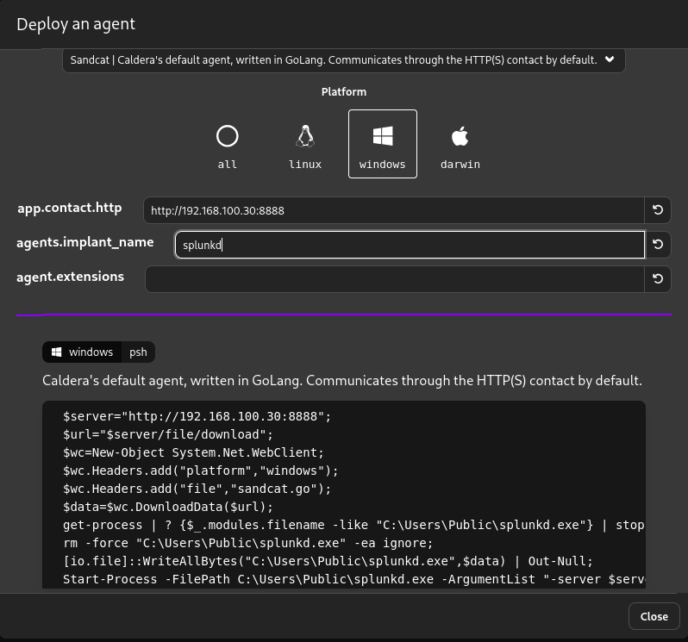
  - Agent "check-in":
  - Once connected, the victim machine will show up as an active agent in Caldera.
  - Adversary profiles can then be launched to simulate attacks.
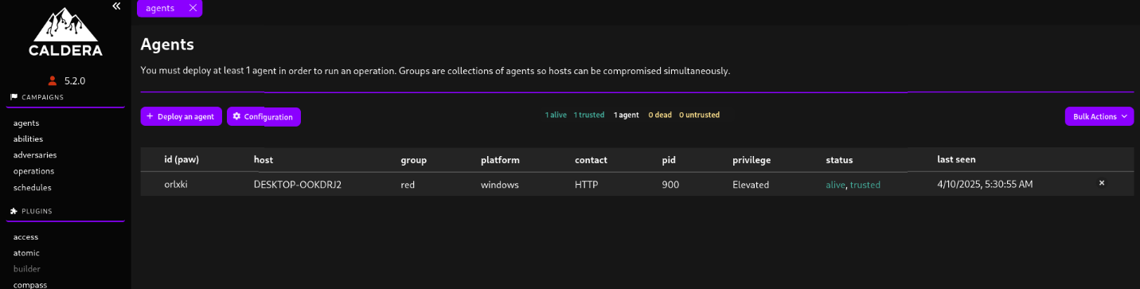

3.3 Simulating Beaconing and Commands
- Select an Adversary Profile
In Caldera:
  - Navigate to the Operations tab.
  - Click + New Operation.
  - Select the agent from the list (the Windows VM).
  - Choose an adversary profile (e.g., Hunter, SilentTrinity, or custom).
  - Click Start Operation.
- Understand the Beaconing Behavior
  - The agent automatically contacts the C2 server at regular intervals (e.g., every 60 seconds).
  - This creates predictable "beaconing" traffic, visible in:
    - Network captures (if monitoring traffic)
    - Sysmon logs (Process creation, network connections)
- Manual Command Execution
  - Go to Agent > Interact
  - Run manual commands like:
    - whoami
    - ipconfig
    - dir C:\Users
  - These actions simulate attacker movement and generate logs on the endpoint.

4. Detection of Suspicious Command Execution via Sysmon Logs in Splunk
Adversaries often perform system reconnaissance and initial foothold validation using built-in commands like whoami, ipconfig, or net user. Detecting these commands provides early warning of a compromise in progress.
These logs are captured in XML format by Sysmon and indexed under a custom Splunk index (win10-victim) with the XmlWinEventLog:Microsoft-Windows-Sysmon/Operational sourcetype.

Splunk Detection Query Example:
index=win10-victim sourcetype=XmlWinEventLog:Microsoft-Windows-Sysmon/Operational
| rex "<Data Name='CommandLine'>(?<CommandLine>[^<]+)</Data>"
| search CommandLine="*whoami*" OR CommandLine="*ipconfig*" OR CommandLine="*net user*" OR CommandLine="*netstat*" OR CommandLine="*tasklist*" OR CommandLine="*systeminfo*" OR CommandLine="*hostname*" OR CommandLine="*nslookup*" OR CommandLine="*Get-Process*" OR CommandLine="*Get-Service*" OR CommandLine="*Invoke-WebRequest*" OR CommandLine="*Invoke-Expression*" OR CommandLine="*IEX*" OR CommandLine="*powershell -enc*" OR CommandLine="*cmd.exe*" OR CommandLine="*pwd*"
| table _time, host, CommandLine
| sort -_time

Explanation of Query:
- rex: Extracts the CommandLine field from XML logs using regex.
- search: Filters for known attacker commands.
- table: Formats output to highlight time, host, and command executed.
- sort: Ensures most recent activity is shown first.

Outcome:
This query provides visibility into adversary behavior and can be used to:
- Perform threat hunting across command-line activity
- Trigger alerts on suspicious command usage

5. Conclusion
This lab successfully demonstrates the simulation of command and control (C2) activity using MITRE Caldera and the detection of that activity using Splunk and Sysmon. By analyzing logs from the victim endpoint, I was able to identify beaconing behavior and gain insight into malicious processes and network activity. This hands-on experience reinforced my understanding of endpoint visibility and log analysis in a simulated threat detection scenario.

